**Ecological modeling – Luna Geerts**

**Model: Olivine dissolution in coastal systems.**

Goal of the model is to calculate how long it takes for x amount of olivine to dissolve fully in seawater. For our purposes we always used 10 grams of olivine (per m2 seafloor)

Olivine dissolution is described by:

$$R= r_{diss}*A_{surface}{*C}_{olivine}$$

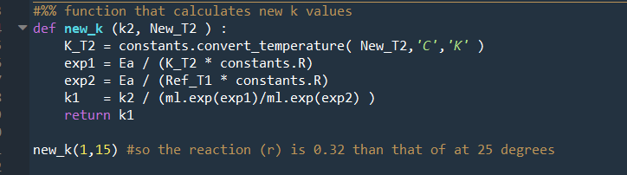rdiss is the rate of olivine dissolution (units mol m-2 month-1), Asurface is the (total) surface area, Colivine is the concentration of olivine. rdiss is dependent on temperature which is given by the Ahrrenius equation (line 44) .

The pH dependence is not modelled but found reading the following graph:

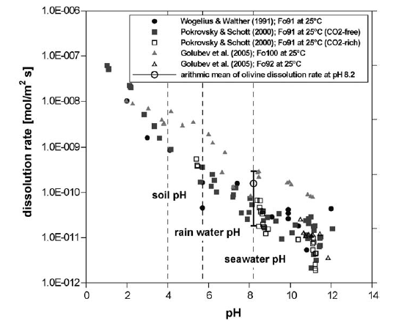

The total surface area of the grain is dependent on the amount of olivine added (as this determines the total volume), starting diameter of an olivine grain is one of the input parameters.

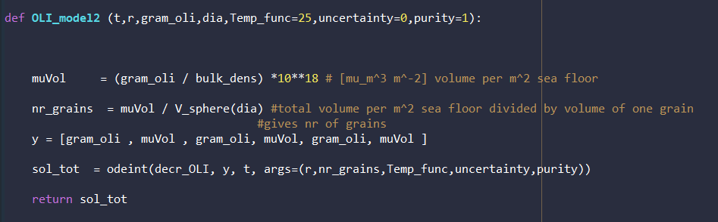The wrapper function “OLI_model2” is what takes care of the volume calculations. It finds the total volume of olivine (knowing the grams added per m-2 seafloor) and the bulk density. Knowing the total volume and volume of one grain (calculated through V_sphere) we can find the number of grains in our model system. The gram of olivine as well as the total volume, number of grains are all passed on to the real model, “decr_OLI”. There are 6 “y” values since we estimate the mass, volume but also the upper and lower boundaries (due to the large uncertainties for rdiss).

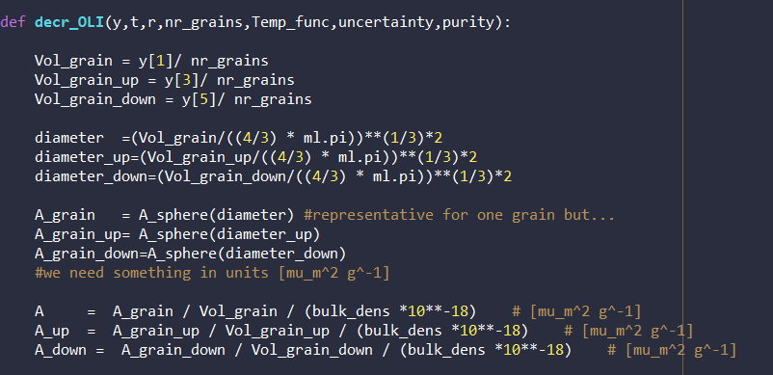The first part of the model decr_OLI determines total surface area. This is achieved by first finding the volume of one grain and then finding the area of a grain. Dividing surface area per grain by volume per grain gives units = m^2 m^-3. Then dividing by the bulk density (gram m^-3) gives m^2 per gram which we need for our model equation.

Afterwards also the temperature dependence is included, the function is found using a polynomial fit: 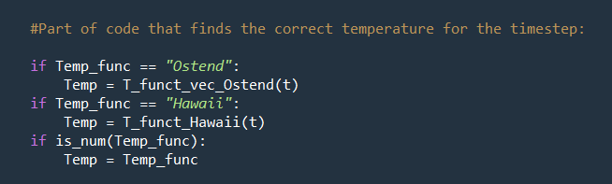

Finally, the dissolution rate is recalculated given the temperature and the units are changed from a mol per second basis to a gram per year basis. Afterwards the gram change is found (dCdt) and also the volume change is found. The if-else part is a messy solution to an issue I had where the volume of Olivine became so small that errors occurred during the solution procedure, and as a consequence the model behaved quite “violently”. This if-else part prevents this, besides at volumes this small nearly all olivine is dissolved either way. In the end, the mass change (dCdt), volume change (dVoldt) is given and their upper and lower estimates as well given a certain uncertainty.

